MyAgencyVault Functionality

**Application High Level Business**

* Commissiondept(Owner Or super User) will sell this aplication to its customers(Agencies). Agencies will use this application to track its Policy Commisions, Information etc.
* Commissiondeptwill get comissions based on Licenses.

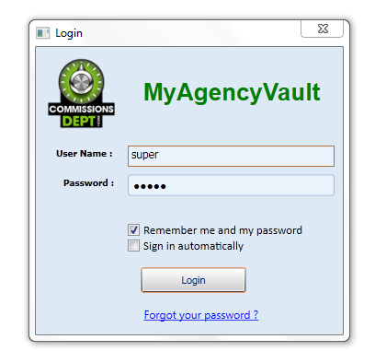

**Description**

* 3 Type of Users : Super User, Brokers(Called Agency also), Data Entry Users
* For any new version developed , below Screen will appear for end users to download the New version

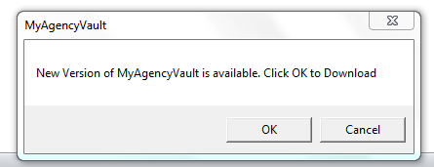

Modules

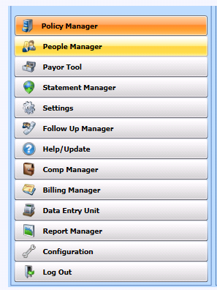

1. Policy Manager

**Description**:

* This screen used to create the clients with selected Agencies, add the policy, policy schedules, to get updated information on Policies, Manage the payments schedules, manage the payment issues, Manage the Policy settings, Maintain the policy related notes, Users can search their policy based on clients from navigation pane search panel.
* Sub modules/Tabs are



* 1. Policy details

Commissiondept /Agency of particular license can manage their policies.

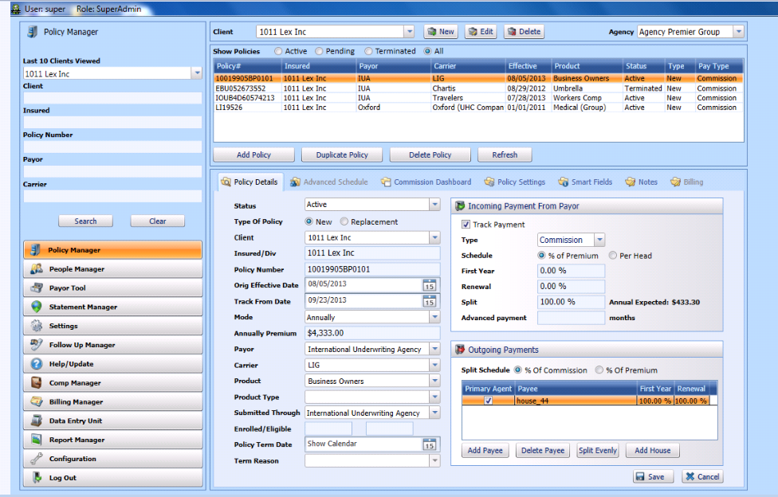

* 1. Commission dashboard

Commission Dashboard will display the data for one policy at a time, selected in top grid of Policy Manager with incoming and outgoing payment and missing issue of selected policy.

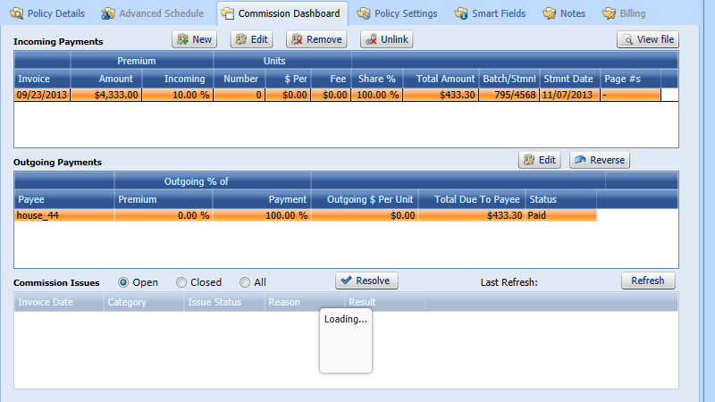

* 1. Policy settings

Commissiondept system to track policy payment missing information. Because if department is tracking then he will put charge from licensee

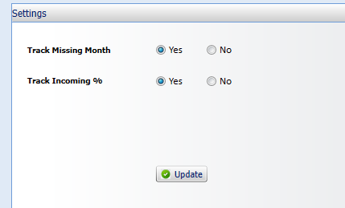

* 1. Policy smart fields

Smart fields/learned fields contain the updated information about the selected policy.

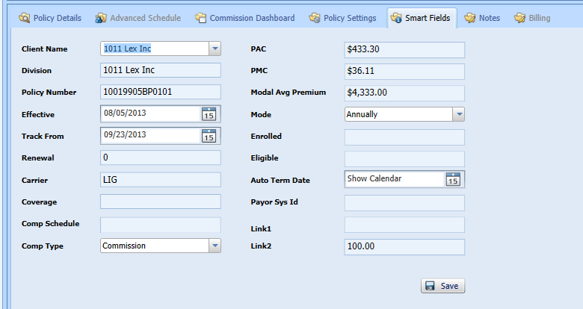

* 1. Policy Notes

On Notes section, user will be able to put a note on the policy into a Grid and save.

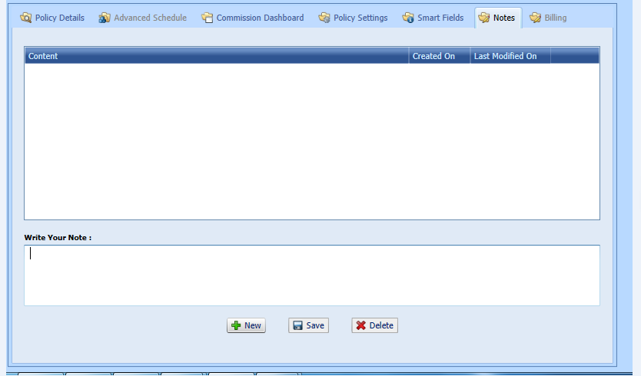

* 1. Create new client

User need to fill the detail of window and click on save will add the new client.

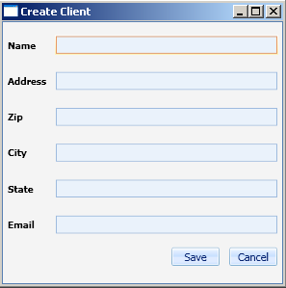

2. People manager

**Description:**

People Manager Screen manages users, contact information, payees, default settings, passwords and permissions for selected agency.

* People manager has two tabs



Main screen:

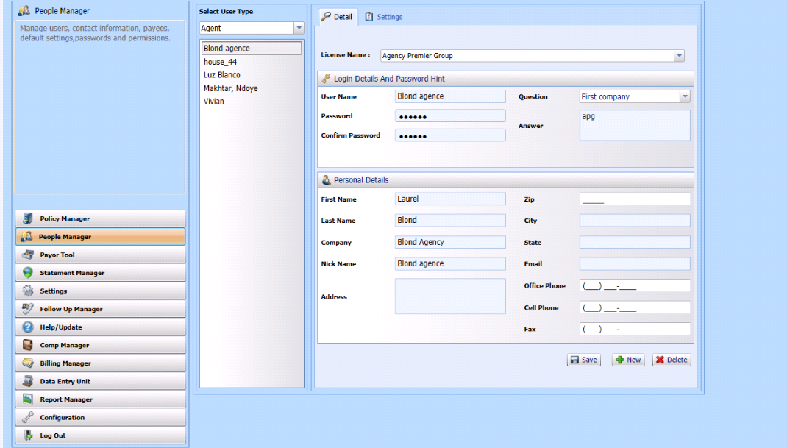

2.1 People manager -Details:

Managesusers andpasswords,contact information of agent /administrator of Licensee.

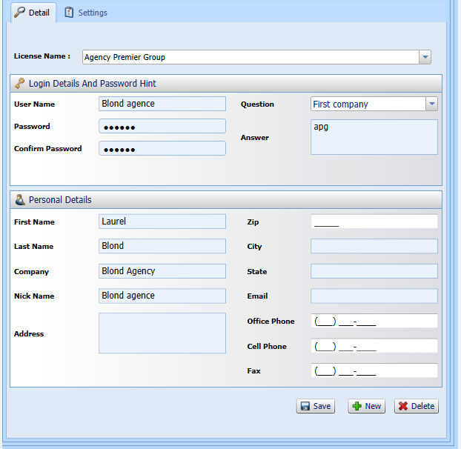

2.2 People manager-Settings

Used to default settings, and permissions of module/screen to selected user.

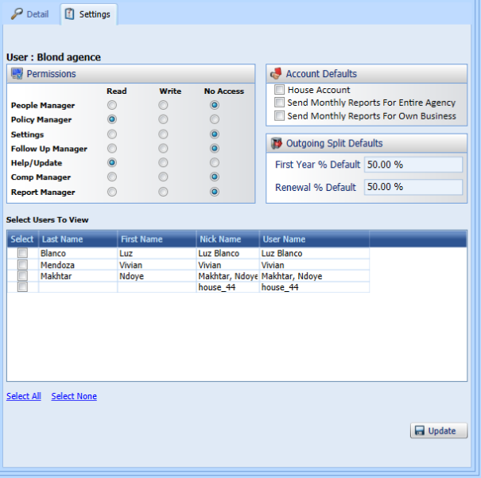

3. Payor tool

**Description**:

Create dynamic data entry template for a Payor.

-Add, delete, create duplicate template of selected Payor.

-Add/update dynamic formula expression.

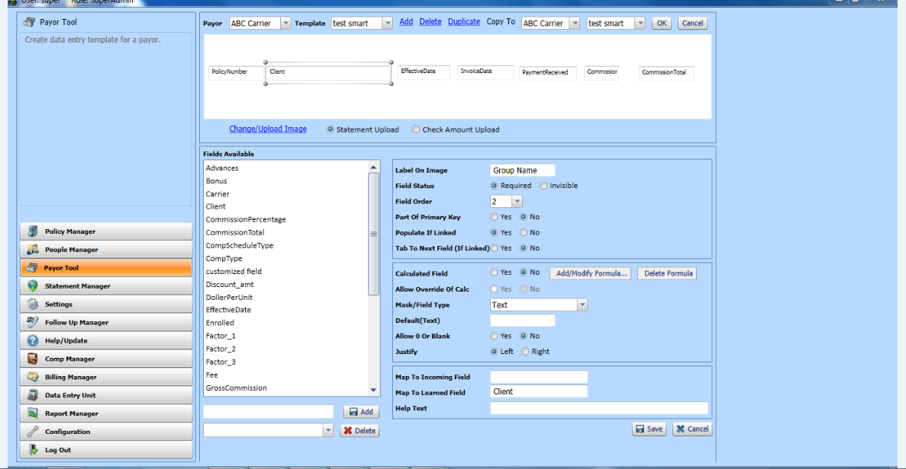

3.1: Add/update dynamic formula expression screen

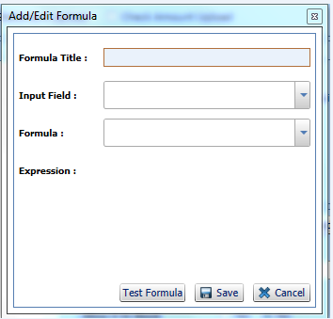

3.2 Add/update Payor template screen

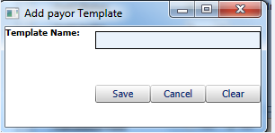

4. Statement manager

**Description:**

Statement manager is used to download online statements from payorswebsites.

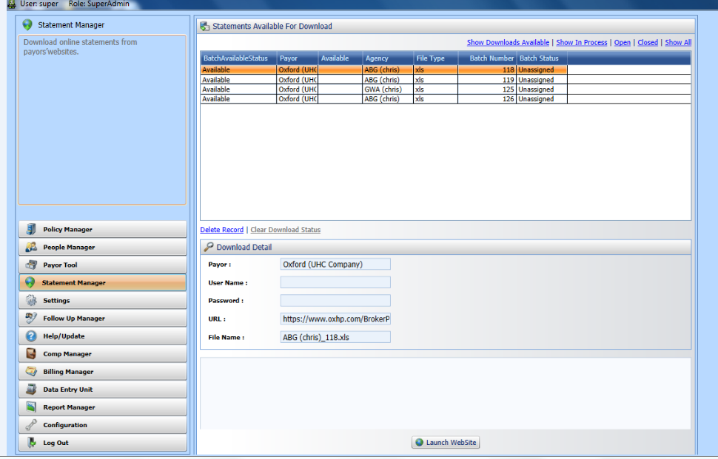

5. Setting manager:

**Description**:

Manage local custom payors, carriers and products. Add specific notes for each Payor including broker numbers. System payors are managed by Commissiondept.Settings manager is responsible for creation of Agency specific Payor called as local payors.

Global Payors created from configuration comes in the settings module. Editing of global Payors cannot be done.

Setting manager has three tabs-



5.1: Setting manager->Payor

Add /update local Payor screen

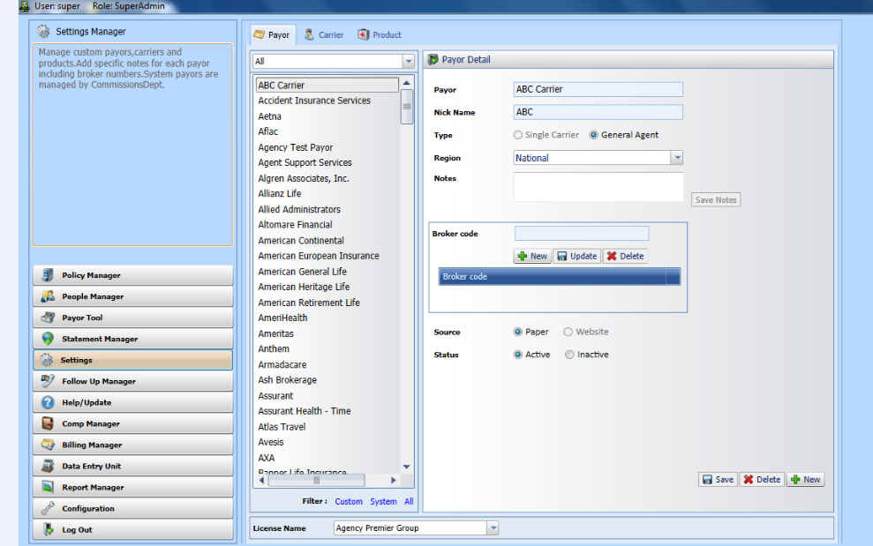

5.2: Setting manager->Carrier

Add /update local carrier screen

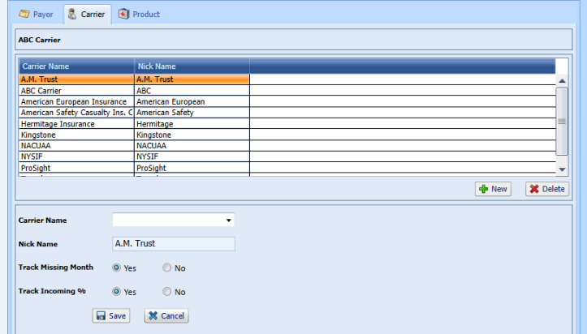

5.3: Setting manager->Product

Add /update local product screen

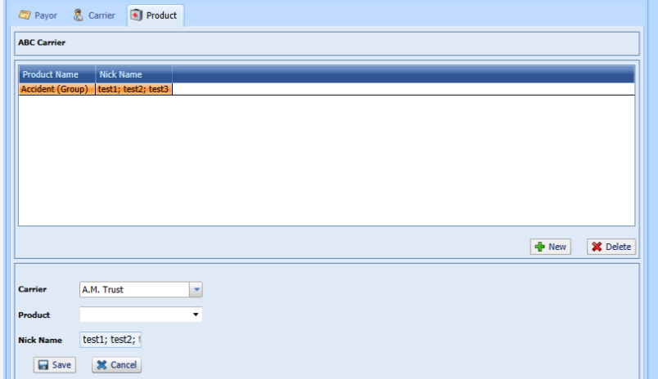

6. Follow up manager

**Description**:

View policies requiring follow up with the payors for missing and incorrect payments.

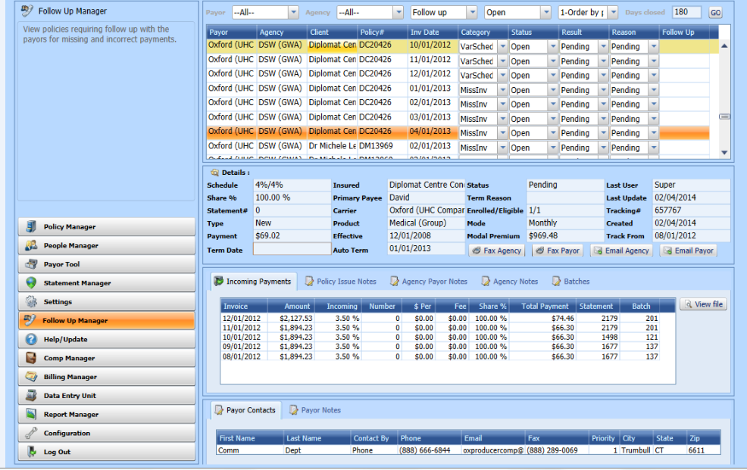

7. Help /update:

**Description**:

View news and updates as well as links to user guides.

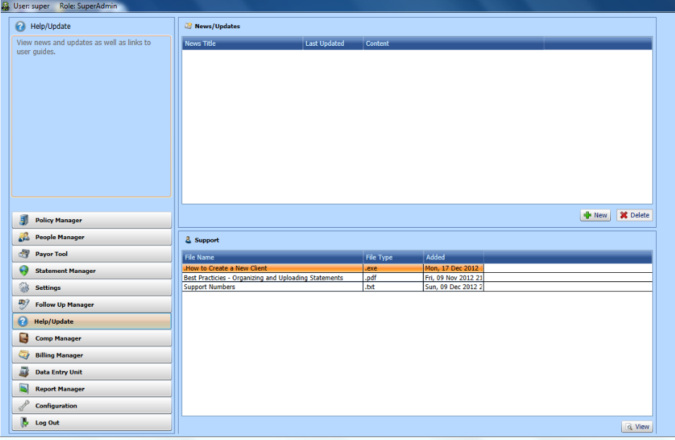

8. Comp manager:

**Description**:

Batch manager allows you to upload new batches and view the status/details of a batch. Link Payment to Policies allows you to assign payments to an existing policy or create new policies from payments.

Comp manager has two tabs:



8.1. Batchmanager:

Batch manager allows you to upload new batches and view the status/details of a batch

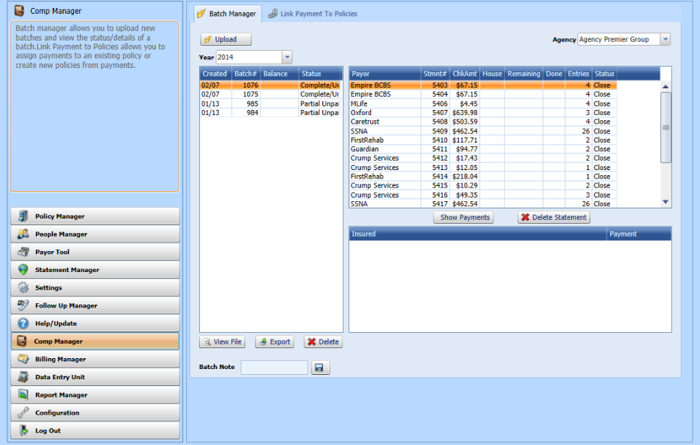

8.2. Link payment to policy:

Link Payment to Policies allows you to assign payments to an existing policy or create new policies from payments

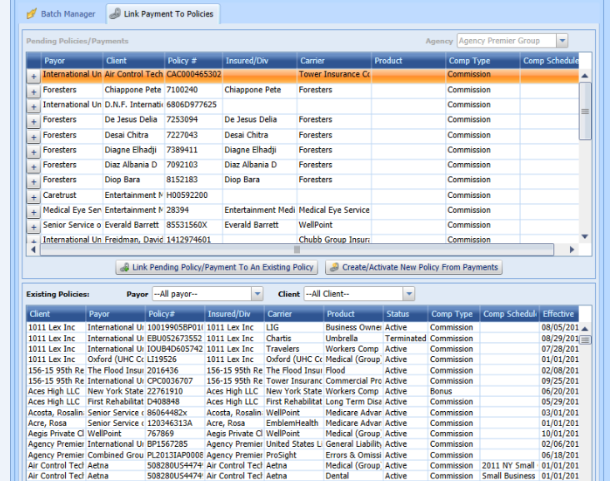

9. Billing manager:

**Description**:

Commissiondept can use this module to generate new Licenses, generate bills/invoices to licensees in Batch, manage journals information, explore the invoices into the system, generate “Billing Data” info text file, intended to be used to for Credit Card payment, provide “payment status” text file for maintaining the journal.

Billing manager has three module/tabs

9.1. Licensee:

Commissiondept can use this module to generate new Licenses.

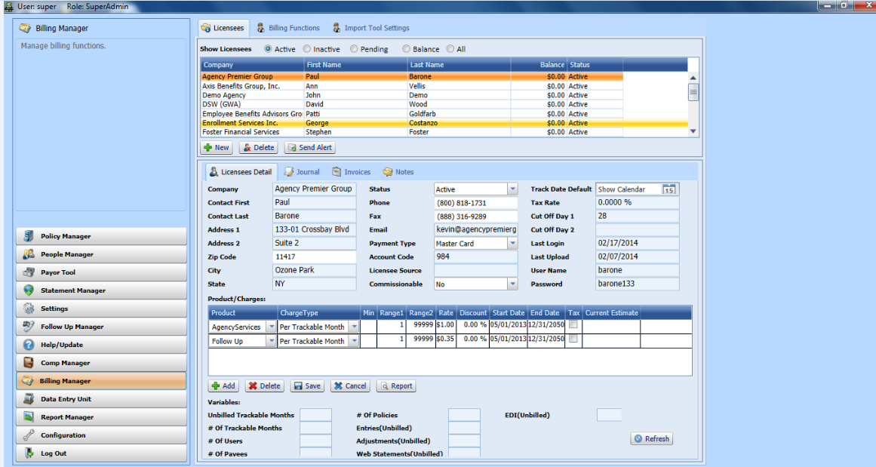

9.2 Billing function:

Generate bills/invoices to licensees in Batch

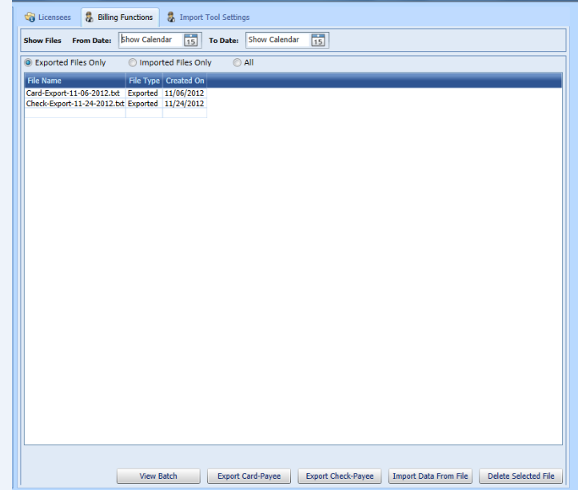

*9.3 Import tool settings:*

Import tool setting are used to configure the import tool service. Super user adds, delete and duplicate the Payor template and its field’s location on the basis of spread sheet file.

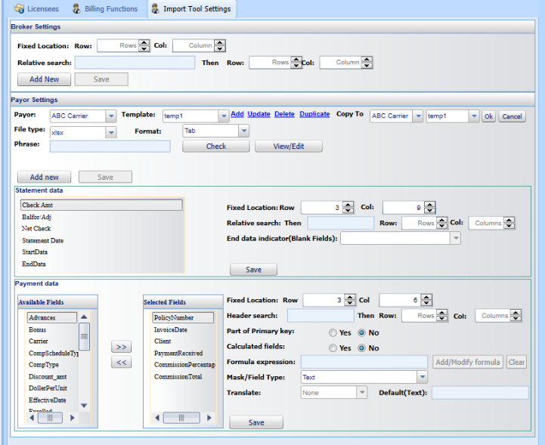

*10. Data entry User (DEU)*

Data entry user uses this screen and enters commission statement data which provided by the Payor.

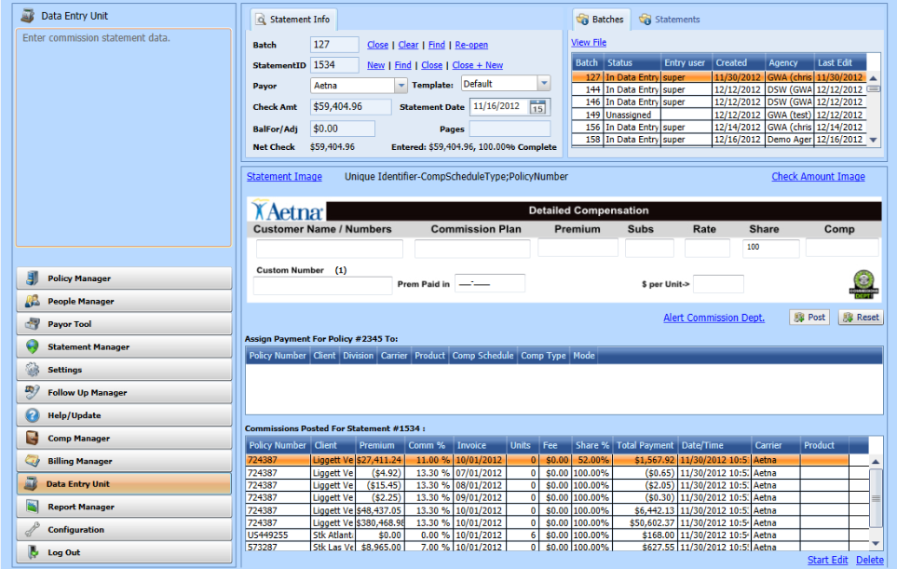

*11. Report manager:*

Create, view and print reports including payee statements, management reports and payment audit reports. Scroll over the report to read a description.

Report has three categories:



*11.1. Payee statement report:*

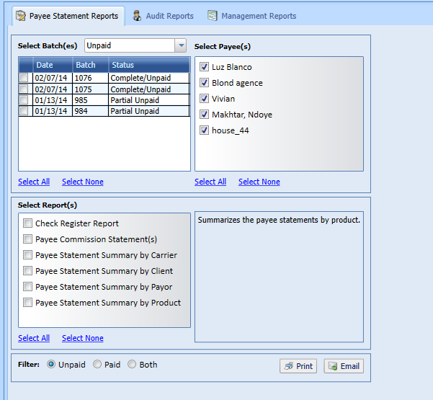

*11.2 Audit reports*

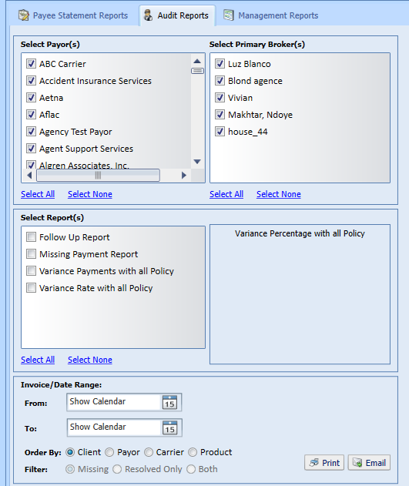

*11.3. Management report*

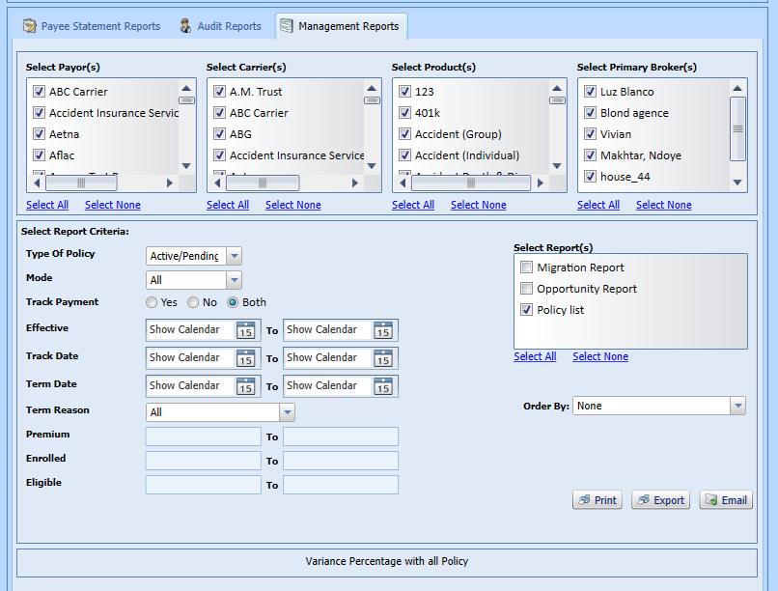

*11. Configuration*

Manage global payors, contacts, carriers and products.Global Payors created from configuration comes in the settings module. Editing of global Payors cannot be done in setting manager.

Configuration has 6 Module/tabs.



*11.1 Payor:*

Add/ update global Payor.

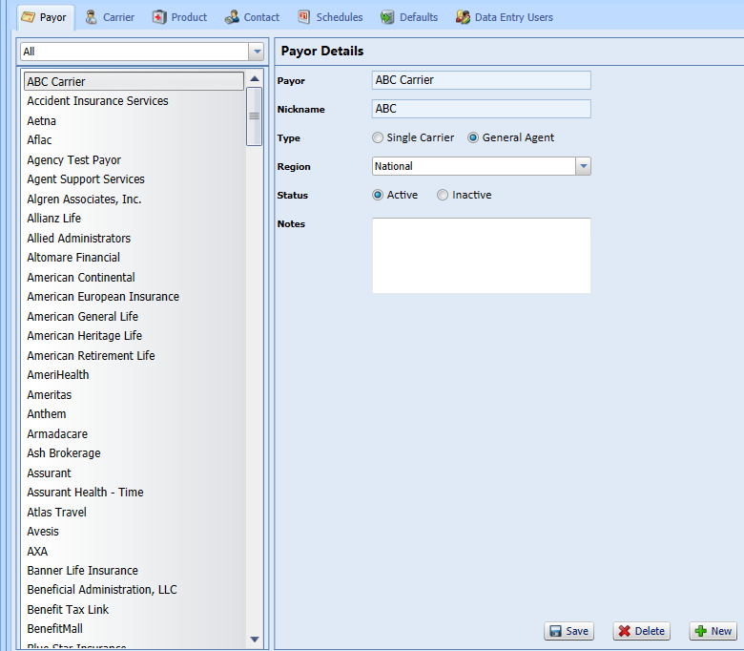

*11.2: Carrier*

Add/ update Carrier for Payor.

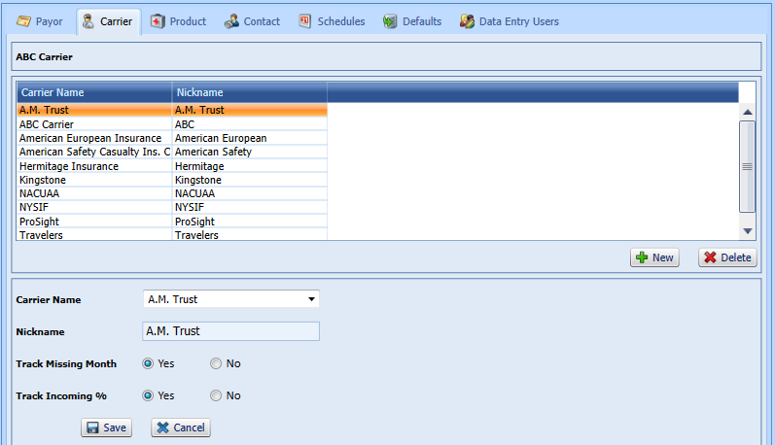

*11.3: Product*

Add/ update Product for Payor and carrier.

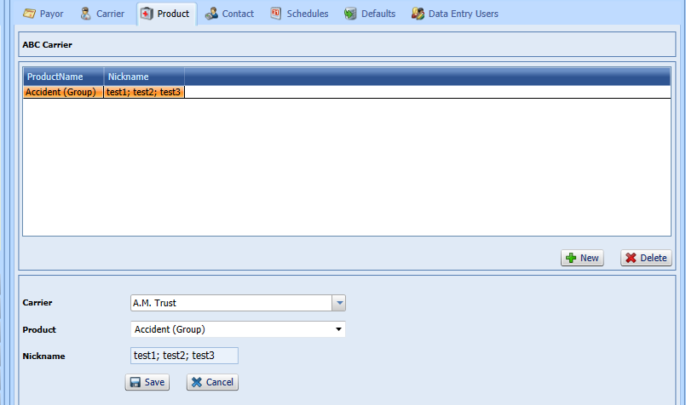

*11.4.Contact*

Add/update the contact information of selected Payor.

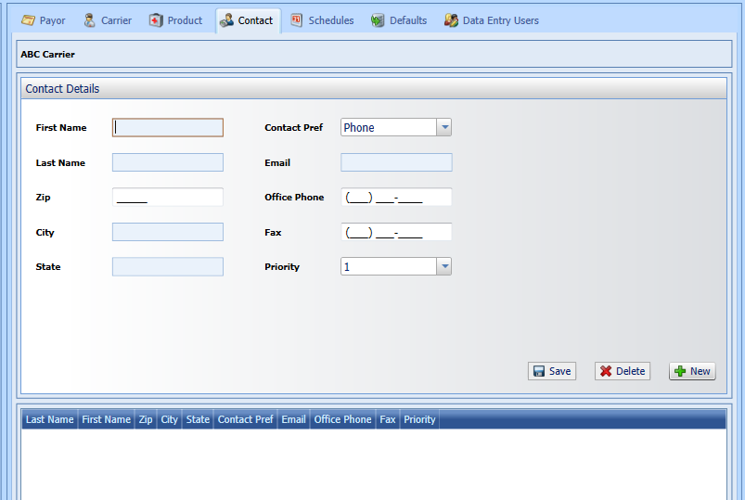

*11.5 Schedules*

Add/update default schedule (incoming and outgoing), follow up service, statement date for selected Payor.

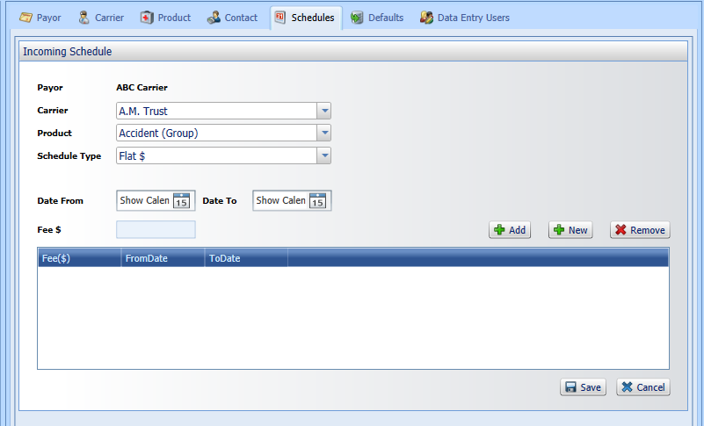

*11.6Default*

Add/update default setting for follow up service, import property, Payor login information, statement date for selected Payor.

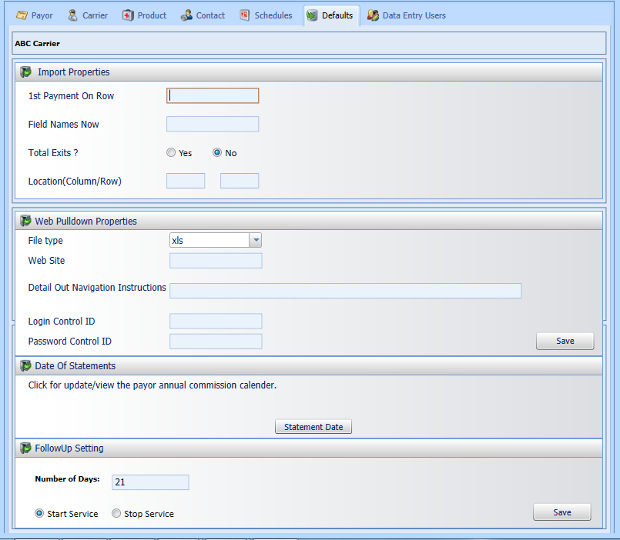

*11.7. Data entry user:*

Create data entry user credential by super user.

